**DBMS Assignment 2**

**M.M. : 20 ( 5 MARKS PER QUESTION )**

**Q.1. Consider the following schema:**

Suppliers(**sid: integer**, sname: string, address: string)

Parts(**pid: integer**, pname: string, color: string)

Catalog(**sid: integer, pid: integer**, cost: real)

The key fields are underlined, and the domain of each field is listed after the field name. The Catalog relation lists the prices charged for parts by Suppliers.

**Write the following queries in relational algebra**

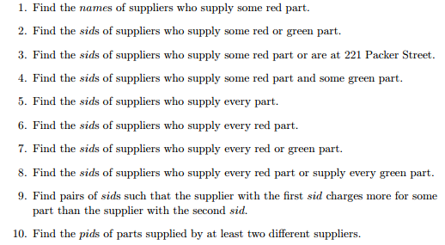

**Q.2. Consider the Supplier-Parts-Catalog schema from the previous question. State what the following queries compute:**

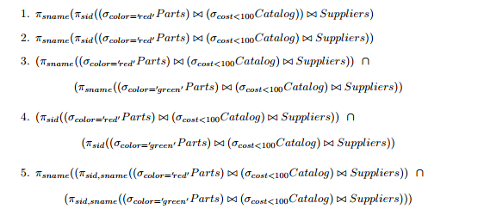

Q.3 **SQL queries involving joins and aggregate functions**. Consider the following relations :

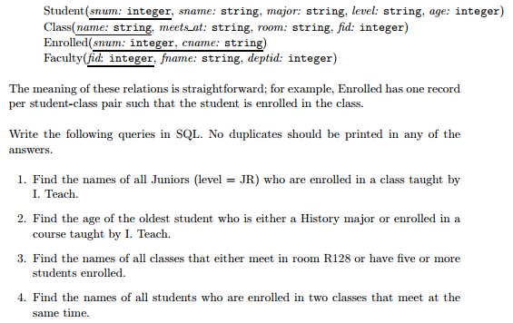

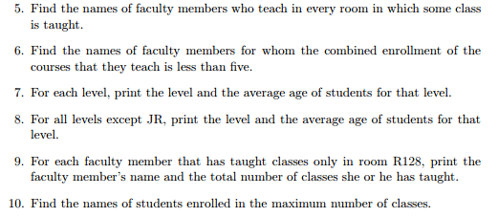

**Q.4. Briefly answer the following questions :**

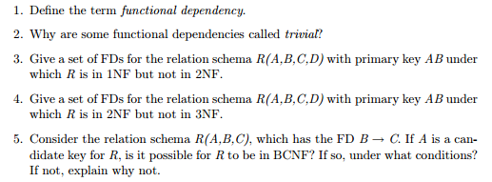

Q.5. Suppose you are given a relation R with four attributes ABCD. For each ofhe following sets of FDs, assuming those are the only dependencies that hold for R.

Do the following:

(a) Identify the candidate key(s) for R.

(b) Identify the best normal form that R satisfies (1NF, 2NF, 3NF, or BCNF).

(c) If R is not in BCNF, decompose it into a set of BCNF relations that preserve the dependencies.

